“Math is All Around Us”

By Darian Vander Veen
Math Instructor

Perhaps you’ve heard a thousand times that “Math is all around us” but here at Aardvark Learning our Math tutoring program asks for students to stop and think that math is everywhere in life and we use Math everyday. This is what makes Math essential is that understanding and mastering math is the key to understanding and mastering any other subject that you want to learn.

Are you into music? Do you like to play an instrument? Have you tried to figure out how to tune your guitar, but find that you are simply unable to figure out exactly where your tuning note is? You can actually hear how far off you are by playing with some sort of sound at your tuning note, and I can explain exactly how that works with math.

Sound Waves and Sinusoidal Functions

Sound travels in waves. If you look at the graphs on the right (and you’re familiar with sinusoidal functions), you’ll be able to see exactly what’s being plotted.

Let’s imagine the red wave is the wave you’re trying to tune to. The blue wave is what your instrument is playing. The green wave is the combination of the two, as you can see on the left if you’re familiar with function notation(if not, don’t despair, the lightbulb moment comes soon). The green wave is also the important one, so let’s look at it alone:
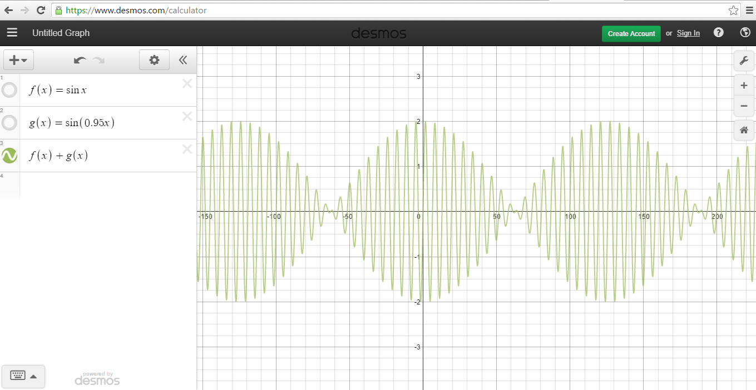

Can you see how the wave pulses? The really important part here, is that you can hear these pulses. The sounds of the two sources combined will pulse maybe 4-15 times a second, depending on how bad you’re out of tune. The secret lies within that 0.95. For the blue wave, the magic number is 0.95. For the red wave, it’s 1. The closer the two magic numbers are together, the less pulses you’ll hear, and the closer to in tune you’ll be. You can duplicate this on www.desmos.com and check it out for yourself by changing that 0.95. If you make it 1 like the red wave, the pulses will disappear

If you’re tuning your guitar, and you hear the pulses sort of disappear, you’re now in tune, and this is why. If you understand this, you’ll be able to tune your instruments, even if you don’t have an ear for it. This is how I tune, because I can’t tell you if my guitar is flat or sharp to save my life.

Math & Sports: What is the best way to strike a ball?
Sports appear to be as far apart from math as possible, there’s no way math could help with your game, right? Wrong. Sometimes in sports, you have to hit an object as far as you can.

You may notice that hitting it into the air helps, but what’s the best way to do it? If you hit it straight upwards, sure, it will go high, but it won’t go forward. So maybe you just want to kick it outwards. However, it’ll hit the ground before it goes anywhere.

The best way to hit it is somewhere in the middle as the Math in the Graph shows:
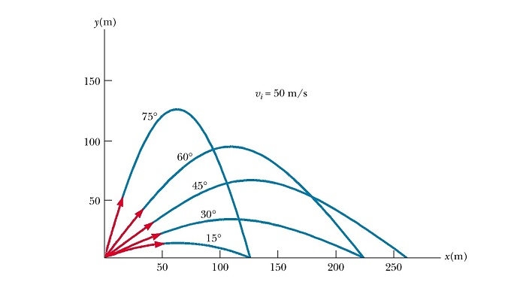
From this graph, you can see that “the middle” I’m talking about is at 45 degrees. And this is where math is handy, because you probably wouldn’t come to this conclusion just by kicking a ball over and over. Maybe you’d kick it with less speed sometimes, and more speed other times. Perhaps you can’t see what angle you’re kicking it at(neither can I), and you can’t really tell what the best angle is just by kicking the ball. But now, you can see the angle, and aim for it next time you’re practice soccer, or golf, or whatever.

But where’s the math? Or you might not ask that, you may be content with the result and leave. If you’re interested, however, I’ll give you the formula for how far the ball will go, and we’ll be able to see how the math is applied to reach it.
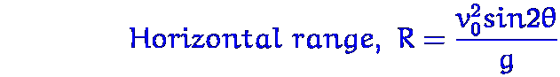
Ouch. That’s a doozy. We can make this easier, though. R is how far the ball will go, so that’s simple enough. v₀² is the initial velocity squared. Basically, the harder we kick it, the farther it will go. Let’s just pretend we’re always kicking our hardest, because we want to get the ball as far away as possible. Then we can ignore it. g is the force of gravity. You can’t kick a ball as far on Jupiter, because gravity is heavier there, but you can kick a ball way farther on the moon. However, on Earth, gravity is basically always the same, so we can ignore that as well.

Now we’re left with something like R = sin (2θ) That funny symbol is the Greek letter theta. It’s just the angle we’re kicking at. Now, if you plot this using www.desmos.com, you’ll find that the highest it reaches is 1, at 45 degrees. Again, this is the result we came to earlier, and now you have the mathematics behind it. If you’re familiar with sinusoidal graphs, you can take this a step further by seeing that the high point of sin (θ) is 1 at 90 degrees. What’s the point, you ask? Well, if sinθ reaches a maximum at 90 degrees, sin2θ will reach its maximum at half that, 45 degrees, because 2 times 45 is 90. If you understand that, then you don’t even need a graph to understand all of this math behind kicking a ball. You can see that now you have something to aim for when you’re trying to master the surprisingly complex art of kicking a ball as far as you can.

Perhaps you like to play video games instead. Video games run off a series of formulas. Maybe they calculate something that’s random chance. Maybe the formulas work together to calculate how much damage you deal in a situation. There’s also that range of a projectile formula, that could be used in a sports video game, or rather, any game in which something is launched into the air somehow. So let’s consider these formulas. What’s the advantage to learning about them? For those of you who don’t play video games, I’d wager you’ve still heard of Pokemon somehow. You know, the game where you catch small animals in balls and have them fight for you? Morality issues aside, let’s look at the formula for catching a Pokemon, shall we? Simple, right?
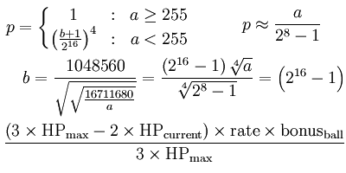

And how do you figure that out? Simple. By understanding the math behind it.

You can start by checking out this video. It’s just over a minute long, but in that short time, it has a lot of interesting visuals, connections, and yes, math.

https://www.youtube.com/watch?v=whYqhpc6S6g

