Mr. V’s MATH QUIZ
Grade 12 Differential Calculus

This Math Quiz is designed to explore concepts surrounding Grade 12 Differential Calculus. Please send answers, questions and comments to the Math Quiz Master by email: aardvarklearning@gmail.com, we will respond asap.

Math Quiz
Name:____________________

- Use the difference quotient to calculate the derivative of f(x) = x²+3x+5. (3 marks)

2. Use the power rule to calculate the derivative of f(x) = 2x⁹+3x³-x+16. (1 mark)

3. Calculate the first, second, and third derivative of f(x) = sin(x)+3x²+8x+14. (3 marks)

4. Use the chain rule to calculate the derivative of f(x) = sin(4x)+cos(2x²+3x+2)+tan(3x). (3 marks)

5. Use the product rule to calculate the derivative of f(x) = (2x²+3x)(cos(x)). (2 marks)

6. Use the quotient rule to calculate the derivative of f(x) = (x³-2x-4)/(2x+5). (2 marks)

7. (4 marks)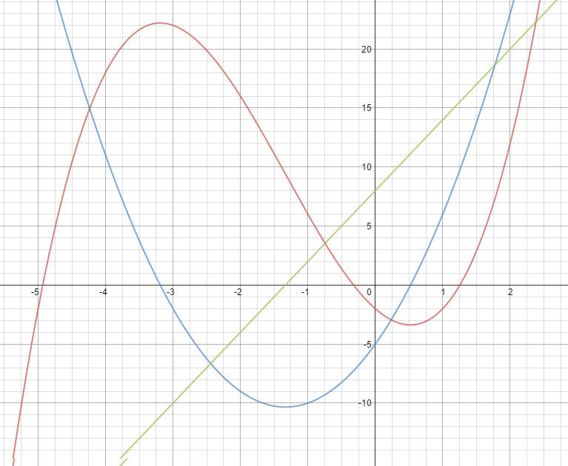

These three lines represent a function, its derivative, and its second derivative. State which is which, and use the second derivative to roughly state the intervals of concavity for the original function.

8. Derive implicitly: y²+2xy = 3x. (3 marks)

9. Bananas And You Inc. has recently started production of only the finest bananas. Their top sales prediction expert has modeled their profits, and believes their profits can be modeled by the function f(x) = -0.03x³+x², where x represents thousands of bananas sold, and f(x) represents profit in thousands of dollars. The company can produce a maximum of 30 000 bananas (Hint: x = 30). Unfortunately, on the way to his business meeting, he fell down a hill and hit his head pretty hard, and has amnesia as a result. Now he needs your help analysing the data.

Determine (approximately) the optimal number of bananas that should be produced to maximize profit. Additionally, state how much profit the company will make after selling that many bananas. (5 marks)

10. (Bonus) Calculate the anti-derivative (Hint: going from f ‘(x) to f(x)) of the following function: cos(x)+6x. (2 marks)

Total: /26

Please send answers, questions and comments to Math Quiz Master by email: aardvarklearning@gmail.com, we will respond asap.

